Theme | Topic | EYFS | Year 1 |  | Year 2 |  | Year 3 | Year 4 |  |  | Year 5 | Year 6
Relationships, Families and Friends | Friendships | Why should we take turns? | How can I make Friends? |  | What should friends do if they feel upset with each other? |  | How can I build positive friendships? | What do online friendships look like? |  |  | How might friendships change over time? | What is the impact of loneliness?
Relationships, Families and Friends | Hurtful Behaviour and Bullying | What is kind behaviour? | What is unkind behaviour |  | What is bullying? |  | Can I spot unkind behaviour or bullying? | What is cyberbullying? |  |  | What is the impact of bullying? | What is discrimination?
Relationships, Families and Friends | Families and Close Relationships | How can we show care at home? | Why is family important? |  | How are all families different? |  | What are different types of relationships | What does a healthy family look like? |  |  | What does diversity in relationship look like? | What does a healthy committed relationship look like?
Relationships, Families and Friends | Additional Content | Antibullying Week lesson plans Monday 16th-20th November 2026  Anti-Bullying Week 2026: Break the Silence X 1 week
Staying Safe | Online Safety | What is the internet? | What do people use the internet for? |  | Should people believe everything online? |  | Is the internet a good thing? | What is personal data and how is it shared online? |  |  | How can people use social media safely? | What’s real and what’s fake online?
Staying Safe | Safety in and outside the home | How do we stay safe at home? | How can people stay safe and happy at home? |  | Who keeps us safe? |  | What hazards are at home and how do we make them safe? | What keeps you safe when you go out? |  |  | How do rules and restrictions keep people safe? | What should people do in an accident or emergency?
Staying Safe | Safety in and outside the home | How do we stay safe at school? | How can people stay safe and happy out and about? |  | What are age restrictions and why are they important?
Staying Safe | Safe Relationships | Which adults keep us safe? | What is privacy and what should be private? |  | Which adults are safe to talk to? |  | What makes a respectful relationship? | What are personal boundaries and what is consent? |  |  | What are the risks of online relationships? | How can pressure put people in danger?
Staying Safe | Safe Relationships | How do we play safely with friends? | What are personal boundaries? |  | How can people stay safe when someone talks to them online?
Staying Safe | Additional Content | Safer Internet Day  Tuesday, 9 February 2027  United Kingdom Safer Internet Centre X 1 week
Health and Well Being | Physical Health | Where does our food come from? | Why are exercise and sleep good for us? |  | How can we stay safe in the sun? |  | How do exercise and sleep improve our health? | What makes a healthy diet? |  |  | How can healthy habits help us? | How do good hygiene and medical care support us?
Health and Well Being | Physical Health | How do we stay clean? | What foods are good for us? |  | How can we stop germs from spreading?
Health and Well Being | Mental Health and Drug Education | What are feelings? | What are the names of different feelings? |  | How can people get help with their feelings? |  | How can feelings change over time? | How can people look after their mental health? |  |  | What support is available for mental health? | How do people manage transitions?
Health and Well Being | Mental Health and Drug Education | When should we try new things? | What harms or helps people’s bodies and minds? |  | What things can people do to feel better? |  | How do people manage difficult emotions? | How does loss impact people’s emotions? |  |  | Why are smoking, vaping and alcohol harmful? | How do drugs impact people?
Health and Well Being | Additional Content |  |  |  |  |  |  |  |  |  |  | DAaRT  X 10 Lessons
Health and Well Being | Additional Content | Children’s mental health week 1st-7th February 2027  Children's Mental Health Week - Place2Be X 1 Week
Theme | Topic | EYFS | Year 1 |  | Year 2 |  | Year 3 | Year 4 |  |  | Year 5 | Year 6
Personal Development and Social Responsibility | Money | How do we pay for things? | What is money? |  | What do people do with their money? |  | How do people choose to spend their money? | What are the risks of gambling? |  |  | How do people use money sensibly? | How do people budget and look after their money?
Personal Development and Social Responsibility | Additional Content |  | Money Matters  X5 lessons |  | Making Money Choices  X 5 lessons |  | Money in the Modern World  X 5 Lessons | Managing Money  X 5 Lessons |  |  | Smart Money Decisions  X 5 Lessons | Money in the Real World  X 5 Lessons
Personal Development and Social Responsibility | Growing and changing | What can we do when we get older? | What are the names of the different body parts? |  | What are the names of the different body parts? |  | What changes happen as we grow up? | What are my personal responsibilities as I grow up? |  |  | What happens during puberty? | What is reproduction?
Personal Development and Social Responsibility | Growing and changing |  |  |  |  |  |  |  |  |  |  | How can my identity help me in a new school?
Personal Development and Social Responsibility | Respecting Ourselves and others | What can we learn about others from stories? | How are people the same and different? |  | How can people be kind? |  | How do people show respect? | How can I respectfully manage conflicts? |  |  | Why does being different make the world interesting? | How do we respectfully disagree?
Personal Development and Social Responsibility | Respecting Ourselves and others | How can we be kind to ourselves and others? | What does it mean to be in a group? |  | What is community? |  | Why is diversity in a community a good thing? | Why should we respect living things? |  |  | How do stereotypes and prejudices impact people? | What is the difference between rules, rights and laws?
Personal Development and Social Responsibility | Additional Content  Additional Content |  |  |  |  |  |  |  |  |  | Mini-Police  X 10 weeks
Personal Development and Social Responsibility | Additional Content  Additional Content | Protected Characteristics Book Curriculum
Personal Development and Social Responsibility | Additional Content  Additional Content | You Choose  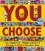 | Elmer  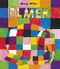 |  | The Great Big Book of Families  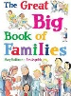 |  | Just Ask  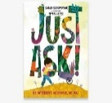 | Dogs Can’t Do Ballet  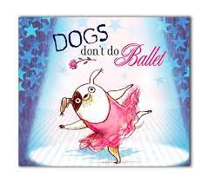 |  |  | Where The Poppies Now Grow  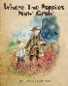 | Julian is a Mermaid  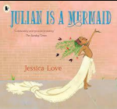
Personal Development and Social Responsibility | Additional Content  Additional Content | Red Rockets and Rainbow Jelly  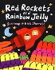 | Ten Little Pirates  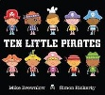 |  | The First Slodge  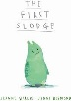 |  | This is Our House  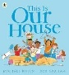 | King and King  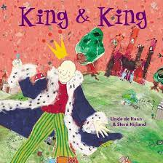 |  |  | Rose Blanche  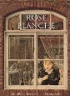 | The Whisperer  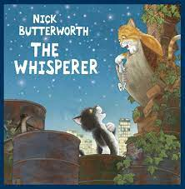
Personal Development and Social Responsibility | Additional Content  Additional Content | Blue Chameleon  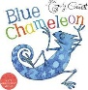 | My Grandpa is Amazing  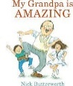 |  | The Odd Egg  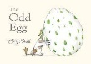 |  | Two Monsters  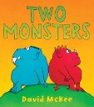 | The Way Back Home  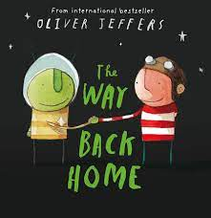 |  |  | How to Heal a Broken Wing  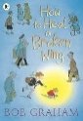 | The Arrival  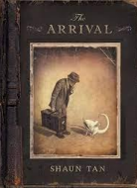
Personal Development and Social Responsibility | Additional Content  Additional Content | The Family Book  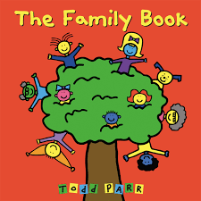 | Max The Champion  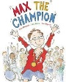 |  | Just Because  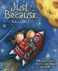 |  | The New Jumper  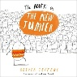 | After The Fall  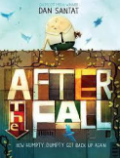 |  |  | The Island  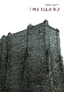 | Love You Forever  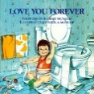
Personal Development and Social Responsibility | Additional Content  Additional Content | Mummy, Mama and Me  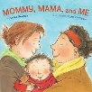 | My World, Your World  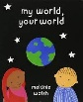 |  | Blown Away   |  | Beegu  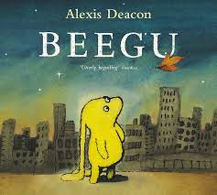 | Red  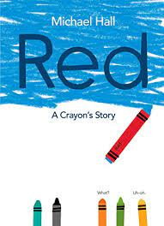 |  |  | And Tango Makes Three  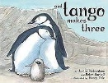 | Dreams of Freedom  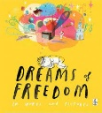
Personal Development and Social Responsibility | Additional Content  Additional Content | Dachy’s Deaf  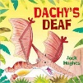 | My name is not refugee  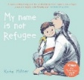 |  | The Proudest Blue  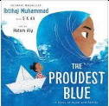 |  | My Shadow is Pink  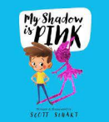 | Perfectly Norman  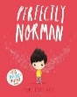 |  |  | Stand Up, Stand Out  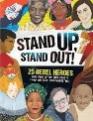 | I Talk Like A River  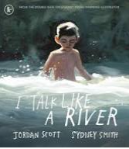
Personal Development and Social Responsibility | Additional Content  Additional Content | Anti-racism Lessons
Personal Development and Social Responsibility | Additional Content  Additional Content | We are All Wonderful | Shine Bright, Be Proud |  | Be an Upstander |  | Be the Change | Different Together |  |  | Change Starts with Us | Make Room for All
Personal Development and Social Responsibility | Additional Content  Additional Content | What Makes Me, Me? | What Makes Me Shine? |  | Words Can Hurt |  | I Am Every Good Thing | I Am Enough |  |  | My Identity, My Story | Celebrating Our Diversity
Personal Development and Social Responsibility | Additional Content  Additional Content | It’s OK to Be Different | Same But Different |  | Be an Upstander |  | What Makes Me, Me? | Respect for Everyone |  |  | Understanding Racism | Understanding Prejudice
Personal Development and Social Responsibility | Additional Content  Additional Content | Seeing Through Someone Else’s Eyes | Uniquely Me |  | Every Colour Matters |  | Understanding Race and Racism | Celebrating Diversity |  |  | Breaking the Stereotype | From Non-Racist to Anti-Racist
Personal Development and Social Responsibility | Additional Content  Additional Content | Same, Different, Special | All About Us |  | The Upstander Superhero |  | Be Anti-Racist | Recognising Racism |  |  | Challenge the Stereotype | Recognising Discrimination
Personal Development and Social Responsibility | Additional Content  Additional Content | All the Colours of Us | Every Shade is Beautiful |  | Stand Up, Speak Out |  | Stand Up to Racism | Our Anti-Racist Charter |  |  | Change Starts With Us | Empathy in Action
Personal Development and Social Responsibility | Additional Content  Additional Content | Proud to Be Me | Kindness Stands Up |  | What Would You Do? |  | Be the Change | Together We Stand |  |  | Our Voices, Our Change | Make Room for All
Personal Development and Social Responsibility | World of Work | See Careers
Careers | Grow throughout life  Grow throughout life by learning and reflecting on yourself, your background, and your strengths. | Who can help me? | Who can I trust to ask for help? | What am I good at? |  | What does success look like? |  |  | How can stereotypes affect careers? | What are skills? |  | How do challenges help you grow?
Careers | Create Opportunities  Create opportunities by being proactive and building positive relationships with others | What can I sell in my magical shop? | Can we run a shop together? | What would I like to do in the future? |  | Who can help me improve? |  |  | How do different jobs work together? | Which jobs might be needed in the future? |  | What is it like to set up a business?
Careers | Balance life and work  Balance your life as a worker and/or entrepreneur with your well-being, other interests and your involvement with your family and community | What is work and what is rest? | How can I volunteer? | What happens when you start a job? |  | How can I balance work at school and at home? |  |  | Why do people do different types on work? | Why do people work for charities? |  | How can I manage money/
Careers | See the big picture  See the boig picture by paying attention to how the economy, politics, and society connect with your own life and career. | What can we learn about jobs from a story? | How are jobs in the past different to now? | How can schools and jobs protect the environment? |  | How does technology impact jobs? |  |  | Do stories contain accurate careers information? | How can we prevent harmful work? |  | How might working life change ion the future?
Careers | Explore Possibilities  Explore the full range of possibilities open to you and learn about recruitment processes and the culture of different workplaces. | What jobs are there in school? | What jobs do people around me do? | Why do some jobs have uniforms? |  | What are career sectors? |  |  | How do subjects at school link to jobs? | What skills do people need for different jobs? |  | Why are qualifications important for jobs?
Careers | Manage Career  Manage your career actively, make the most of opportunities and learn from setbacks. | Do people enjoy their jobs? | Who do I look up to? | Why do we go to school? |  | What is a career journey? |  |  | How can I achieve a goal? | How can I make a good decision? |  | How can I prepare for change?
Careers | Additional Content | Finance Education X5 lessons for each year group- Financial Education lesson suggestions.docx  Enterprise Week- Autumn Term  Careers Week -Summer Term

