Home Learning Week 4
This week’s theme is ‘animals’
Weekly Maths Tasks  Aim to do 1 per day  - Working on Times Tables Rock Stars - your child will have an individual login to access this.  - Play on Number Fact Families - find the addition and subtraction fact families for numbers up to 20, 50 or 100.  - Practise counting in 2s, 3s, 5s and 10s. This game could support this.  - Go out in the garden and observe the different creatures/animals that can be seen. Create a chart to present this data, such as, a tally, pictogram or bar chart.  - Practise learning about money by playing this game. You could also use real coins and play a similar game with family members.  - Select a number between 2 and 100. Make a poster showing how many different ways to make this number using addition, subtraction, multiplication etc. | Weekly reading tasks  Aim to do 1 per day  - Can you read fiction, non- fiction and poems about animals?  - Can you find adjectives in the books used to describe the animal?  - Listen to the stories: https://www.storylineonline.net/books/clark-the-shark/  https://www.storylineonline.net/books/library-lion/  - Create a bookmark with animal facts  - Read common exception words and time how long it takes for you to read them all. Can you beat your score by the end of the week?
Weekly writing tasks  Aim to do 1 per day  - A-Z Animal list: Can you think of an animal for each letter of the alphabet. Can you add sound buttons?  - Draw a picture of your animal and label it. Can you write sentences using expanded noun phrased and conjunctions?  - Write a set of questions about animals you would like to find out about.  - Create a fact file about your favourite animal. Research an animal of your choice and explore the vocabulary required to describe them.  - Describe similarities and differences between animals. | Weekly phonic tasks  Aim to do 1 per day  - Daily phonics - your child to practice their sounds and blend words. Interactive games found on link below.  - Phonics play  - Top Marks  - Spelling  - Spell the days of the week  - Spell common exception words  - Spelling City  - Practise weekly spellings  

Learning Project - to be done throughout the week: animals
The project this week aims to provide opportunities for your child to learn more about key animals they are interested in. Learning may focus on exploring the physical aspects of an animal, their habitat, categorising animals etc.
Find out about:
What are mammals?
What are amphibians?
What are birds?
What are fish?
What are reptiles?
What are minibeasts?
https://www.bbc.co.uk/bitesize/topics/z6882hv

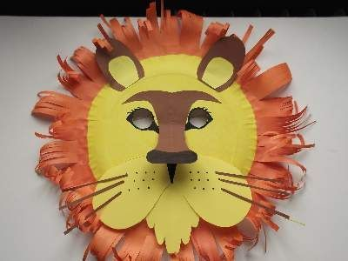
Create a mask: Using different materials around the house, create a mask of their favourite animal. Think about the colours and shape. Can they add different textures to their mask?

Where does your animal live? Play this sorting activity to develop their understanding of where different animals live.
Animal grouping: Get your child to group animals into two columns. Identifying animals that can fly and cannot fly. What do animals eat? Scientists group animals into three different groups according to what animals eat. These groups are carnivores, herbivores and omnivores. Carnivores eat other animals, herbivores eat plant material including fruit, leaves, vegetables, omnivores eat a mixture of meat and plant material. (Animals that eat other animals are called carnivores. Animals that eat plants are called herbivores. Animals that eat both plants and other animals are called omnivores)
Sorting Cards
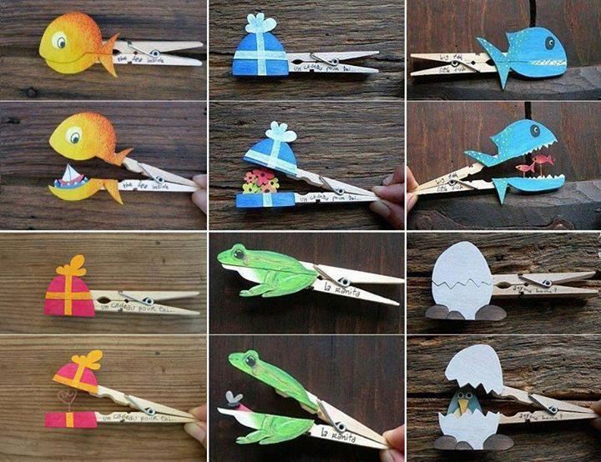
Needs of an animal. Can all animals be kept as a pet? Think about a particular animal and find out if that animal could be a pet. Draw pictures of different animals. Sort the animals into two groups; suitable for a pet and not suitable for a pet. Explain why animals were sorted in a particular way. www.rspcaeducation.org.uk/teachers - Design a leaflet explaining to potential pet owners what each animal will need. - Interview a pet owner to discuss the responsibilities involved with looking after an animal. How often do they need to find their pet? Who helps clean? What does their pet eat? Find some pegs at home. Can you create your own mini animal or object, cut it in half and stick it to a peg?

Nocturnal animals - What do they think this word means? Watch and discuss the animals they saw. Have they seen these animals? How could they describe them? Play Nocturnal animals are more active at night than during the day. These animals sleep during the day, often in a burrow or den. They have special adaptations that help them survive in the dark. Over millions of years, these animals have developed traits that help them survive in the darkness. Nocturnal animals may have larger ears to hear better, bigger eyes to see better, and body parts that glow in the night. Create your own big-eyed nocturnal animal art.

Additional learning resources parents may wish to engage with
Classroom Secrets Learning Packs - These packs are split into different year groups and include activities linked to reading, writing, maths and practical ideas you can do around the
BBC bitesize This website now has daily lessons and has links to every aspect of the curriculum and is child friendly. (English, Math, Science, History, Geography)

