Home Learning Week 5
This week’s theme is ‘Environment’
Weekly Maths Tasks  Aim to do 1 per day  - Play on Number Balance - play all levels. Make the scales equal by ensuring that both sides total the same value.  - Practise counting in 2s, 3s, 5s and 10s. This game could support this.  - Look out of your window or stand in your front garden and count how many cars go past. What is the most popular colour that passes? What is the least popular colour that passes?  - Practise telling the time. This could be done through this game (scroll down to access the game). Read to the hour, half hour and quarter of the hour.  - Choose a number between 10 and 100. How many different ways can this number be partitioned? Do bigger numbers have more ways they can be partitioned? | Weekly reading tasks  Aim to do 1 per day  - Listen to the information video about caring for the environment. Discuss with your child after. Watch  - Read a story that has a woodland in.  https://www.youtube.com/watch?v=qjgugbdwvMY  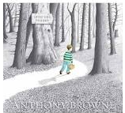  - Find and read a book aloud about materials. Discuss the materials you find and place them in alphabetical order.  - Place the words onto paper and read them out aloud: environment, recycle, reuse, conserve. Can you put the sound buttons on?  - Listen to Newsround and discuss what has been happening in the world this week. What new things have you found out?
Weekly writing tasks  Aim to do 1 per day  - Write a ‘thank you’ letter to the people who collect your rubbish and recycling. What could you include in your letter? Can you think of any questions you could ask about recycling or where the rubbish goes?  - Can you label the plants in your garden or in the house?  - Write a weather report. Can you use any adjectives?  - Write a set of clear instructions on how a rainbow is made.  - Design a re-cycling poster. | Weekly phonic tasks  Aim to do 1 per day  - Daily phonics - your child to practice their sounds and blend words. Interactive games found on link below.  - Phonics play  - Top Marks  - Spelling  - Spell the days of the week  - Spell common exception words  - Spelling City  - Practise weekly spellings  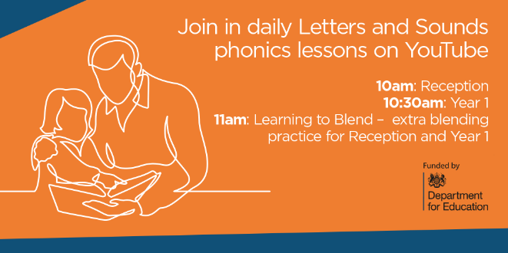
Learning Project - to be done throughout the week: environment
The project this week aims to provide opportunities for your child to learn more about the environment. Learning may focus on changes to different environments, the impact of humans on environments, climate change etc.
Create a chart to record the weather. Label the chart with days of the week and record the weather at different points in the day. Can you write down key words and take a photograph of the sky. Does it change in the week? This link may help.
Watch the weather report on T.V. How do they describe the weather? What do you notice about the map? Can you find Retford on the map? Have they got symbols when they are talking about the weather?
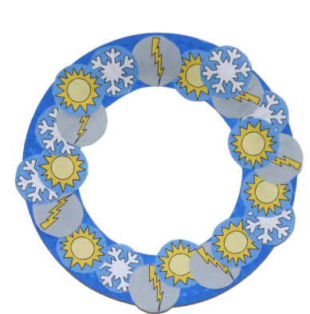
Weather reporter: Pick a day that you would like to present as a weather reporter. Can you create some symbols to use when you are talking about the weather? Can you talk about the weather in your local area and maybe compare to another place in the UK?
Create a weather wreath. Using different materials can your child design a weather wreath? Encourage them to think about the symbols used in your weather report.
What a load of rubbish! With your child look at the rubbish as a family you throw out. Do you help to recycle? How do you sort these into junk and into recycling? Look at the range of items and group them into different material groups. Talk to a family member about how certain groups are plastics and can also look and feel different to each other. Could you design a new way to help recycle more items? Ideas
Beat the clock- Can you sort items into the correct recycling and waste bins? Play
Switch it off: Ask your child to take a look at all the electrical devices in their house. Are they all plugged in? Do they need to be plugged in? Create a poster to place around the house to help remind people to switch it off once they have finished.
Save Electricity: Recycle Paper, Conserve water. What could you include on these? Where could you place these in the house? Can you talk to your family about the posters and how you could help the planet?
Listen to a song about things we can do to help to save the planet.
Write and draw!: Ask your child to choose one thing they could do to help the environment in school. Get them to make a poster to encourage people to do it! Think about the classroom and also the school.
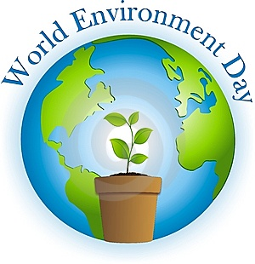
World Environment day- This year it will be on Friday June 5th. On this day people from all over the world will do something positive to help our planet. Ask your child what could they do? Lots of little things can make a big difference. What could they do to celebrate World Environment Day at school? Can they create a poster to display at school?
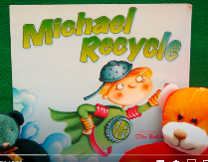
Storytime. – Listen to the story Michael Re-cycle
https://www.youtube.com/watch?v=aZj14ChIY8I
Additional learning resources parents may wish to engage with
Classroom Secrets Learning Packs - These packs are split into different year groups and include activities linked to reading, writing, maths and practical ideas you can do around the
BBC bitesize This website now has daily lessons and has links to every aspect of the curriculum and is child friendly. (English, Math, Science, History, Geography)
Twinkl - to access these resources click on the link and sign up using your own email address and creating your own password. Use the offer code UKTWINKLHELPS.

