Home Learning Week 7
This week’s theme is ‘Celebrations ’
Weekly Maths Tasks  Aim to do 1 per day  - Play on Daily 10 - play levels 1 or 2 to practise adding and subtracting.  - Practise counting in 2s, 3s, 5s and 10s. This game could support this.  - On a calendar (here is an online calendar if needed) go through and write down when different family members birthdays are or when special events are happening in your family.  - Practise telling the time in words. This could be done through this game (scroll down to access the game). Read to the hour, half hour and quarter past.  - Choose and write the name of a 3D shape of your choice. List how many edges, vertices and faces it has. | Weekly reading tasks  Aim to do 1 per day  - Find a book where you can see the characters celebrating. Is it a birthday? Can you read the book to someone over the phone or on FaceTime?  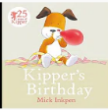  - Read the story Kipper’s Birthday. Discuss how it may be similar or the same to your birthday celebration.  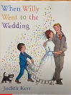  - Read the story When Willy went to the wedding. Have you been to a wedding? Tell someone about the wedding you went to.  https://www.youtube.com/watch?v=5_aknDIHXSE  - Create a celebration book with your family. Can you hear and clap the syllables in the words?  - Create a Celebration Reading Den. What will you have in there? Who can read in there with you? Will you have cushions in there so you are comfortable?  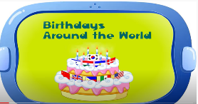  - Talk about how children celebrate birthdays around the world. Write a list of the similarities and differences  https://www.youtube.com/watch?v=7jrTgtX8q9k
Weekly writing tasks  Aim to do 1 per day  - Write an invitation for a celebration. This could be a birthday party, Easter celebration etc.  - Create a list of all of the celebration days they can recall and write a sentence about what they remember about each.  - Invent a story involving a celebration. They could write it out or make a story map. Encourage your child to use story language.  - Create a birthday card for the next family member’s birthday. Try and add a rhyming poem in the middle.  - Write a menu for a special celebration. It could be Christmas dinner or a Diwali feast. | Weekly phonic tasks  Aim to do 1 per day  - Daily phonics - your child to practice their sounds and blend words. Interactive games found on link below.  - Phonics play  - Top Marks  - Spelling  - Spell the days of the week  - Spell common exception words  - Spelling City  - Weekly class spellings  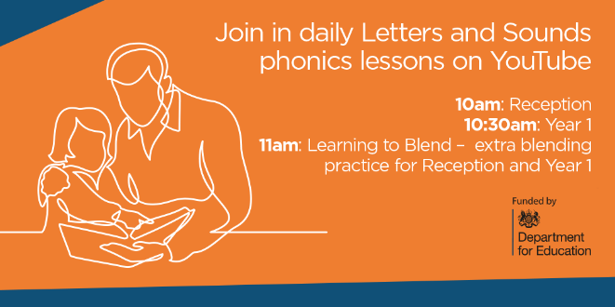

Learning Project - to be done throughout the week: celebrations
This project this week aims to provide opportunities for your child to learn more about celebrations. Learning may focus on different types of celebrations that take place and who may celebrate them. It could look at how people celebrate different events differently in other parts of the world.

What does celebration mean to you?
Watch with your child. Make an A-Z list of celebrations around the world. How many can they find?
What have they celebrated this year with their friends and family? Can they remember celebrating their birthday? How did they celebrate their birthday? Could they draw a picture of their special celebration? Can they interview a family member about their favourite celebration? What did they do? Who can they remember?

Create a celebration card for a family member. - What will they put on the front? Will it be pictures or will they write a birthday poem? Can they use different materials to design their celebration card?

Bake a cake: Weigh out the ingredients and bake a cake for a celebration. Can they write the instructions and send them to a friend? Can they tweet their school with a photo of their cake and instructions?

Design a celebration party: Ask your child to choose a celebration. Who would they invite? Get them to make a list of things they will need? (banners, balloons etc...) Would they have to have a dress code? Can they design a celebration invite? On a piece of paper can they think about the colours and pictures they may have.

Months:
Can your child name the months in order? What do they notice about them? (Look at the letters at the beginning of the month.) Can they think of a celebration for each month they may have with their family? Find out when it’s people's birthdays or anniversaries. Which month has the most celebrations?
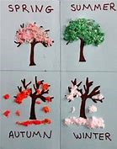
Seasons: Ask your child how many seasons we have? Can they name them?
Watch 1 Watch 2 Ask them to look outside their window and see if they can name the season we are in at the moment. What can they see? Can they see any flowers? Or new buds? Can they draw a picture of what they can see using different materials?
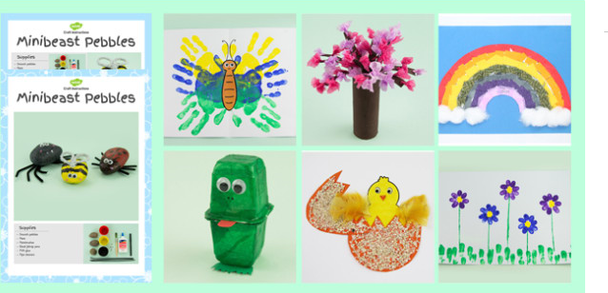

Calendar: Collect some materials to create a Seasons Calendar. Think about the design and what they will need.

Spring is in the air: Spring is around us: Can they look around the house to see what they can use to make a crafty spring project.

Celebrations across the four season:
Think about all of the celebrations we have around the world. Can they name them and place them into the correct seasons?
Autumn: Diwali, Bonfire Night, Harvest Festival , Hanukkah
Winter: Christmas, New Year
Spring: Holi, Easter, Mother’s day
Summer: Father’s day, EID, Vesak

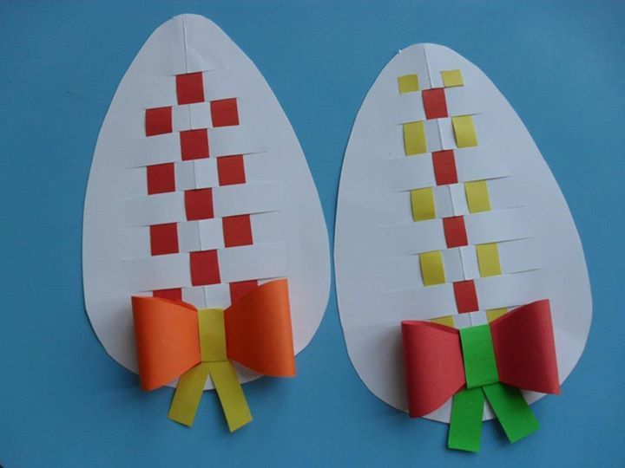
Create a card for each of these celebrations. How will their designs be different? Are there particular colours they can use? Could they make a pop up card? Could they make a card using no pen and only fabric?
Traditional celebration: Talk to an adult and ask about any traditional celebrations you may have as a family. Why do you celebrate them? How do you celebrate them and when?
Do you have to wear different clothes and eat different food?

Gather the family and sing the song ‘Celebration’: Can you add actions to the dance? Could you have a concert and perform to your family and friends?

Additional learning resources parents may wish to engage with
Classroom Secrets Learning Packs - These packs are split into different year groups and include activities linked to reading, writing, maths and practical ideas you can do around the
BBC bitesize This website now has daily lessons and has links to every aspect of the curriculum and is child friendly. (English, Math, Science, History, Geography)
Twinkl - to access these resources click on the link and sign up using your own email address and creating your own password. Use the offer code UKTWINKLHELPS.

