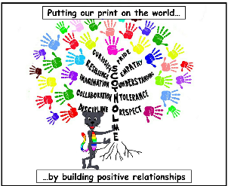
Subject- Design and Technology

Threshold Concepts and Milestones
Threshold Concept |  | Year 6 | Content
Master practical skills  This concept involves developing the skills needed to make high quality products (we have highlighted a range of skills but they may be added to or changed | Mechanics | • Use scientific knowledge of the transference of forces to choose appropriate mechanisms for a product (such as levers, winding mechanisms, pulleys and gears).  • Convert rotary motion to linear using cams.  • Use innovative combinations of electronics (or computing) and mechanics in product designs. | - Chn to explore creating each of the different kind of machines in appropriate contexts- building on from the Physics curriculum.  - Pulleys  - Levers  - Gears  - CAMS  - K’nex - water wheels  - Lego - crocodiles (electronic mechanisms programming)  - Children to evaluate each machine and think about its uses in the ‘real world’.
Design, make, evaluate and improve  This concept involves developing the process of design thinking and seeing design as a process. |  | • Design with the user in mind, motivated by the service a product will offer (rather than simply for profit).  • Make products through stages of prototypes, making continual refinements.  • Ensure products have a high quality finish, using art skills where appropriate.  • Use prototypes, cross-sectional diagrams and computer aided designs to represent designs. | Problem: People with mobility issues struggle to perform everyday tasks.  Design brief: Make a machine that will make life easier for people with mobility issues.  - Chn think of a range of problems that could affect people with mobility issues  - Create designs that would answer the problem (allow chn to be as inventive as possible)  - Children build prototypes using appropriate materials  - Review their prototypes and make adjustments on their plans  - Collaborate with others to compare ideas  - Build a final prototype  - Test and evaluate
Take inspiration from design throughout history  This concept involves appreciating the design process that has influenced the products we use in everyday life. |  | • Combine elements of design from a range of inspirational designers throughout history, giving reasons for choices.  • Create innovative designs that improve upon existing products.  • Evaluate the design of products so as to suggest improvements to the user experience. | - Look at the evolution of products through time e.g. hoover, mobile phones, stair lift, dumb waiter, lazy susan  - Look at a variety of designers  - Annotate how they improved life for the users

