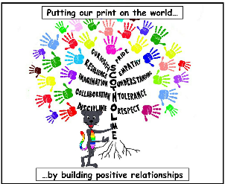
Subject- Design and Technology

Threshold Concepts and Milestones
Threshold Concept |  | Year 4 | Content
Master practical skills  This concept involves developing the skills needed to make high quality products (we have highlighted a range of skills but they may be added to or changed | Textiles | • Understand the need for a seam allowance.  • Join textiles with appropriate stitching.  • Select the most appropriate techniques to decorate textiles (such as dyeing, adding sequins or printing). | Considering how many pieces their toy will have and how it will be joined. As well as the main body of the character, they will attach one piece of decorative detail.  Practise hand / machine stitches: back / double stitch for strengthening seams, running stitch to attach decoration)
Design, make, evaluate and improve  This concept involves developing the process of design thinking and seeing design as a process. |  | • Design with purpose by identifying  opportunities to design.  • Make products by working efficiently and independently (such as by carefully selecting materials).  • Refine work and techniques as work progresses, continually evaluating the product design. | Problem: All the classes in school need a school mascot but there aren’t enough to share around.  Design brief: Make a cuddly toy or puppet that can be used as a school mascot.  - Children write a list of features for a successful cuddly toy/puppet: soft material, cute / appealing appearance, soft materials, washable, strong enough joins / seams to withstand years of use!  - Children research and discuss different mascots.  - They carry out research among peers to see if it is appealing to others. They refine their design in accordance with the feedback they receive.  - Children use their character idea to design a pattern.  - Children choose materials for their toy based on visual and tactile appeal and suitability for purpose.  - They next choose a filling material, again based on suitability for purpose.  - More market research: children ask peers to comment on their design and invite suggestions for improvements.  - Children make their toy.  - Share the mascots they have made with different classes in school and take feedback.  Self and peer assessment of the finished product.
Take inspiration from design throughout history  This concept involves appreciating the design process that has influenced the products we use in everyday life. |  | • Identify some of the great designers in the areas of study to generate ideas for designs.  • Improve upon existing designs, giving reasons for choices.  • Disassemble products to understand how they work. | Children begin by investigating the popularity and history of mascots and their creation as soft toys/ puppets.  When did they become popular?  Why are they popular?  What different designs are there?  What do these designs have in common?  What sort of materials are they made from ? Why?

