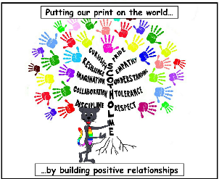
Subject- Design and Technology

Threshold Concepts and Milestones
Threshold Concept |  | Year 3 | Content
Master practical skills  This concept involves developing the skills needed to make high quality products (we have highlighted a range of skills but they may be added to or changed | Materials | • Cut materials accurately and safely by selecting appropriate tools.  • Measure and mark out to the nearest millimetre.  • Apply appropriate cutting and shaping techniques that include cuts within the perimeter of the material (such as slots or cut outs).  • Select appropriate joining techniques (such as gluing, hinges or combining materials to strengthen). | Children to investigate and experiment with using a variety of different materials: paper, cardboard, cardboard boxes, lollypop sticks, plastic bottles, Lego, wooden bricks, recycled materials, milk bottles or cartons. Discuss features of the materials.  Children measure out lengths accurately using ruler and practice cutting and shaping techniques. Use a range of tools to cut and create – scissors, saw etc. Why are some materials easier to cut than others?  How can they create smooth edges? (Filing, sand paper).  How can they attach or join the pieces together? What is required? String? Rope? What types of glue are best? PVA, glue gun, glue stick, hinges?  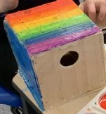  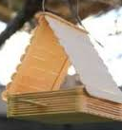  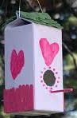  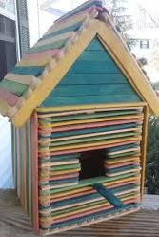  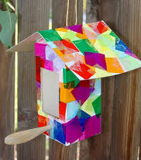  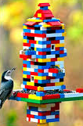
Design, make, evaluate and improve  This concept involves developing the process of design thinking and seeing design as a process. |  | • Seek to solve a problem and design with purpose by identifying opportunities.  • Make products, with guidance (such as by carefully selecting materials).  • Refine work and techniques, at the end of each design phase, to evaluate the product design. | Problem: The population of birds in our local area has increased but there is no shelter for them.  Design brief: Make a waterproof bird box for birds that live in our school grounds.  Children to watch birds in our local area and then count the number of bird boxes they can see. There are more birds than shelters and birds need a safe, waterproof place to nest and escape bad/cold weather. How can we contribute to our environment?  What does a shelter need? What materials could be used? Children to investigate and experiment with using a variety of different materials: paper, cardboard, lollypop sticks, plastic bottles, Lego, wooden bricks, recycled materials, boxes, milk bottles or cartons.  How big should the box be? How big should the entrance hole be? Why?  Have a first attempt with little input. What materials did they use? Why? Test it. What went well and what could go better? If it disintegrates, why? If the pieces fell apart or broke, why? How could you improve it? Draft, sketch ideas and redesign/make. Listen to feedback, evaluate and redesign with improvements.
Take inspiration from design throughout history  This concept involves appreciating the design process that has influenced the products we use in everyday life. |  | • Identify some of the great designers in the areas of study to generate ideas for designs.  • Improve upon existing designs, giving reasons for choices.  • Disassemble products to understand how they work. | 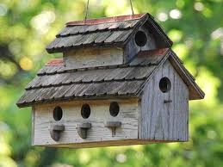  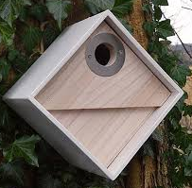  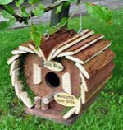  Children to use iPads, computers and books to research bird boxes already designed. Children to handle actual bird boxes of various shapes, sizes and designs. How are they different? What do they all have in common? What materials have been used? Why? Why are some bigger than others? Why do some have large entrance holes and others have small? How many birds does each box hold? What makes them effective/less effective? Why are some materials better than others? Durability, waterproof, strength.  

