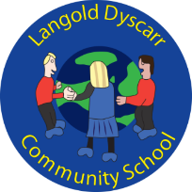
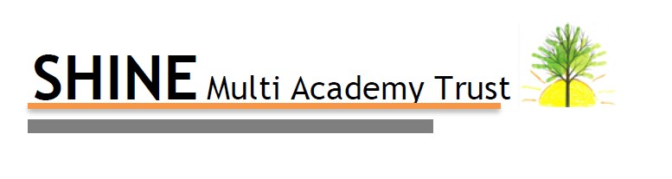
Subject on a Page for: Geography
Intent (What?)
To inspire in pupils a curiosity and fascination about the world and it’s people that will have lifelong impact.
Equip pupils with knowledge about people, resources and natural and human environments.
Deepen their understanding of local geographical features

Implementation (How?)
Plan and deliver a sequenced and coherent curriculum
Develop teachers geographical knowledge.
Identify the key concepts to be taught consistently from foundation to Year 6
Cross curricular links.
Develop KUSP ladders and knowledge organisers that support our curriculum.

Impact (So What?)
The curriculum is more cross curricular and prepares them for the next stage in their learning.
Children will draw on prior knowledge.

On the scale below, rate where you believe this subject currently stands in terms of your overall curriculum provision:

Developing Secure Embedded

Previous Improvement Actions and Impact | Current Improvement Actions | Future Improvement Actions
European Day of Languages  Caterpillar Music  UPDATED DECEMBER 2021  December 2021 –  Staff training on key concepts completed in staff meetings.  Key concepts for Geography highlighted and mapped out throughout the year groups. They clearly show links in subject knowledge and themes in units studied from Foundation to Year 6.  Book Scrutiny carried out – positive. Actions relayed to staff. Everyone working from the same page to ensure continuity throughout school.  UPDATED JUNE 2022  April 2022 – Lesson drop-ins  Very positive. Creative lessons with a range of learning styles.  Positives;  *Provision in KS1  *Range of activities in KS1 - children discovering.  *lap-tops being used for exploration/research across school.  *Re-capping previous lessons in activities including in outdoor learning in KS1  *KS2 – use of knowledge organisers within lesson embedded  *Children eager to learn  *Leading own learning with their own questions.  June 2022 –  Pupil Voice carried out – Showed that most children have a good understanding of geography within their year group.  Showed a good retention of knowledge in areas including; volcanoes, trade, continents and the water cycle.  KS1 children were able to recall facts from more recent topics , but struggled with earlier ones. | Field trips  Orienteering  December 2021 –  Staff editing Knowledge Organisers to work for our children.  Format and key information to be included being discussed as a staff.  2022 –  Knowledge organisers being used in all year groups – key information/vocab included.  Knowledge banks introduced and staff completing as they teach a topic. | Develop links with a foreign School (if possible)  Exploiting world events e.g World Cup, Olympics  Developing Forest schools  Integrating the Lake/wood in learning.  December 2021 -  Audit geography resources across school to ensure that this is not a barrier to high quality teaching and learning.  Decide on format for knowledge organisers and ensure they are being used correctly throughout school. – COMPLETED  June 2022 –  Collate knowledge banks together into a folder for staff use.

