Autumn Term 1
Homework Menu
Please choose one homework challenge to complete each week and bring into school to share with the class.
Watch the movie on You Tube
https://www.youtube.com/watch?v=9h6K0_XrxEI
Disney Robin Hood 1973
Can you tell a friend about your favourite part?
Go for a walk in Dyscarr Woods with a grown up. What can you hear, see, touch? Write a list.
Thank you.
Can you make a Robin Hood hat out of paper.

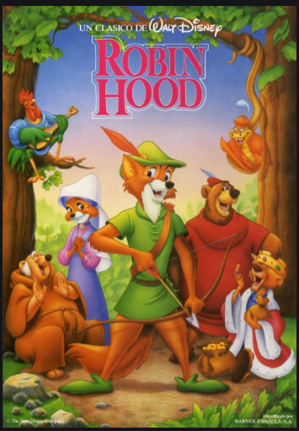
Draw a picture of Robin Hood and colour it.
Create an information
leaflet about Robin Hood.

Remember to use sub-headings
Who was Robin Hood?
Where does Robin Hood live?
Who were Robin Hood’s friends?

Collect as many different leaves as
you can and make a collage picture.
Can you make Sherwood Forest in a box?
Complete the Robin Hood problem solving sheet on the back.

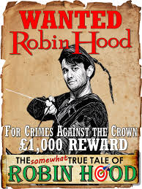
Design a ‘Wanted’ poster for an outlaw.
Find out about
Nottingham Castle.
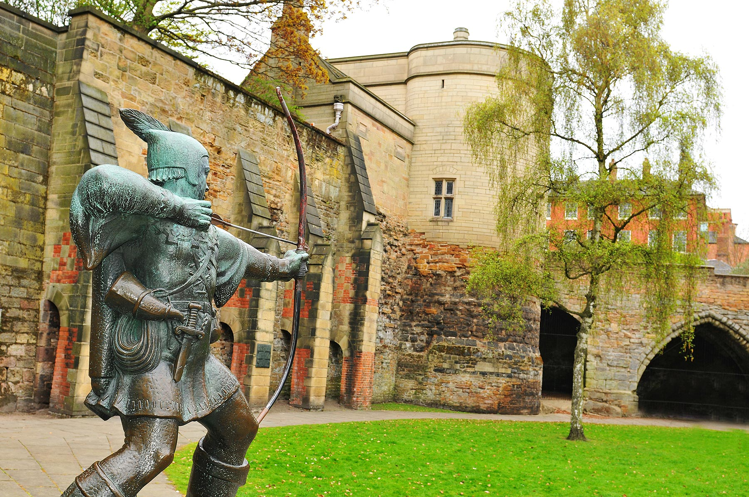

Have fun completing these tasks and we can’t wait to see all of your amazing work.

