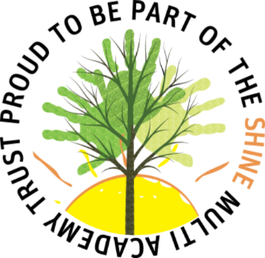



Prehistoric Britain and how People didn't live as long as today.
Egyptian society
Newsround – current affairs

King Tutankhamun being disabled.
Anti bullying
Newsround – current affairs

Chris Winters SRE








PSHEE - Chris Winters SRE
Science animals including humans
Science – life cycle

Similarities and differences of religions (Hinduism, Islam )
Why is god important to religions
What festivals different religions/ communities celebrate. Diwali day
Egyptian Gods

Newsround – current affairs
The Fire Work Makers Daughter – WCR
Black history week
Art – Yayoi Kusama

PSHEE - Chris Winters SRE
History, Stone Age – wife buried with their husband

Prehistoric people, men/woman.
Skeletal system and muscles, men/woman
PSHEE - Chris Winters SRE
History, Stone Age – wife buried with their husband

Orchid Bees
Protected Characteristics
Life Cycles of humans and how we develop.
PSHEE - Chris Winters SRE

