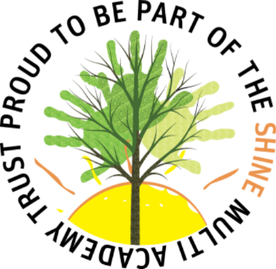



- Celebrating differences PSHE








LLi
- Faith days

- RE Curriculum – Notts Agreed syllabus

- Multicultural books

- Black History Month

- Assemblies/Votes for Schools
- Introduce concept of gender stereotypes RSE
- Exploring differences between males and females RSE
- Me and My relationships PSHE

- Different types of families RSE
- Life cycles SCIENCE

- Animals including humans SCIENCE

- Growing and changing RSE
- Me and My relationships PSHE

- Different types of families RSE
KS1
Protected Characteristics

