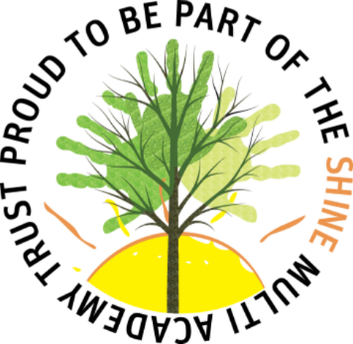



- Differences and similarities

- History of relatives
- Grandparent’s lunch

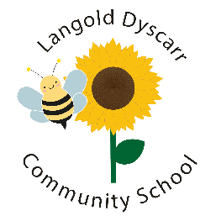






- Christmas
Easter
Chinese New Year
Pancake Day
Christingle
Divali
- The boy who can wear pink

- Multicultural books

- Families

- Families

- hatching chickens
- hatching butterflies
- Life cycles
- Families
Honey Bees
Protected Characteristics

