Non negotiables for Music:
-Retrieval of previous learning
-Verbal feedback
-At least one of the strategies from below for scaffolding.
-key knowledge
Cognition and Learning |  | Communication and Interaction
Subject Challenges for SEND | Provision for SEND | Subject Challenges for SEND | Provision for SEND
Terminology and vocabulary  Low attainment in reading can present barriers to accessing learning. | Use of visual aids to support children’s understanding and learning such as:  -Photograph which is linked to the word  -A definition of the vocabulary as a reminder (could develop a vocabulary bank for this)  -Flash Cards  -Vocabulary word mats  -Create rhymes for the vocabulary  Support in work:  -Recap previous learning  -Key vocabulary word banks  -SEN planning scheme on Charanga  -Small group work  -Opportunities for adults to scribe  -Dyslexia friendly font.  -Sloping board.  -Use ICT e.g. photographs, audio descriptions, where appropriate.  -When writing music, SEND children to have scaffold  -Scaffolding compositions | Language barriers may make it difficult for children to participate in learning.  Barriers in processing language | -Visual prompts.  -Language which focuses on key words and concepts with repetition.  - Signs and symbols where applicable.  -Act out vocabulary e.g. loud and quiet  -I do/you do/my turn/your turn  Support:  Peer talk partners  Small group work led by an adult  Use ICT where appropriate.  Sensory breaks  Learning in small chunks.  Taking one piece of music instead of a larger section  Identify sensory barriers to learning (ear defenders for sensitive hearing)  Use now and next boards.  Prior knowledge of SEMH needs to consider the sensitivity of the task (pre-look at lyrics)
Physical and Sensory |  | Social Emotional and Mental Health
Subject Challenges for SEND | Provision for SEND | Subject Challenges for SEND | Provision for SEND
Children with sensory barriers may find it difficult to visually or auditory access the curriculum.  Children may have physical barriers and may find it difficult to access the learning. | -Children to sit facing the adult.  -Overlays  -Hearing loop  -Ear defenders  -Ipads/laptops to have the Charanga lesson on instead of the big interactive boards  -Signs and symbols where relevant  -Adult and peer support.  -Dyslexia friendly font. | Social and emotional needs can create barriers to participation, interaction, and concentration to learning.  Children may have personal triggers to some aspects of learning. | -Provide sensory breaks.  -Use now and next boards.  -Smart tasks which may be condensed to realistic time scales to incorporate sensory breaks.  -Use ICT where appropriate.  Consider the sensitivity of the task.

WAGOLL:
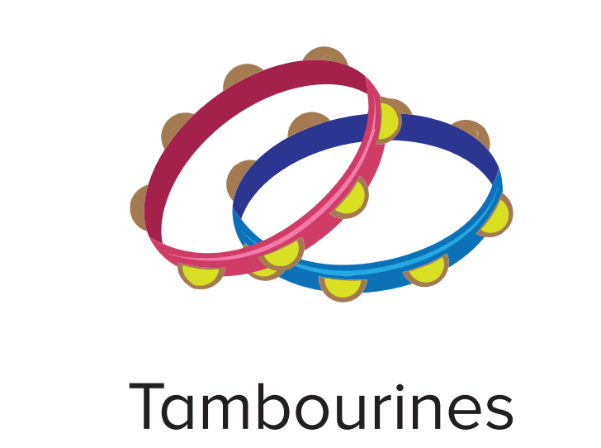
Example of flash cards that can be used for vocabulary:

