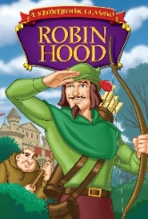 Autumn Term 1 Newsletter.
Year 1 and 2.
Welcome Back,
We hope that you have had a great Summer break and are looking forward to the Autumn Term. Hopefully, this newsletter will inform/remind you of class routines within KS1 and give you an insight into what your child will be doing this half term, so when you ask them what they’ve been doing in school today, you know what ‘nothing much’ or ‘I can’t remember’ really means.

If you have any questions or queries, please send your child’s teacher a message on dojo and we will get back to you as soon as we can.

This week we will be starting our topic called ‘Robin Hood’.

The children will be developing their English and Math skills by engaging in a number of projects related to their topic work. These will include writing a fable/ story, poetry and recounts. In Math, the children will learn how to solve a range of problems involving number, shape, space and measure.

In history, the children will learn about Robin Hood and what life was like in medieval times. They will experience what it would have been like to live in medieval times during their visit to Sherwood Forest by engaging in various role-play activities.
In art and design technology, the children will be developing their painting skills and they will also be designing and making a hand puppet.
In science, the children will be learning about trees and plants and how they grow.
In PE, the children will develop their running, throwing and catching skills, as well as learning dances related to their topic work. Your child’s class teacher will post their PE days on the school website and on Dojo.
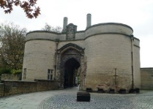

Homework
Your child will bring home a reading book, spelling sheet and home-school diary every night. Please could you listen to them read and help them to practise their spellings on a daily basis. This will then need to be recorded in their home school diary and brought into school every day. They will also bring home a homework challenge at the beginning of each term. Please choose a task to complete weekly and record it in their homework book.

P.E. Days.
Your child will need to come to school in their PE kit. NO JEWELLERY PLEASE. We are hoping to work outside this half term (weather permitting so joggers and a sweatshirt or tracksuit) Please could you ensure that your child’s PE kit and uniform is CLEARLY LABELLED so that it doesn’t get lost.

Sherwood Forest Trip
The children are going to Sherwood forest on Monday 11th October during the normal school times. We will send out further information nearer the time.

If you have any questions or queries, please come in to see us either first thing in the morning or after school. We are available most days.

Thank you for your support
The KS1 team

