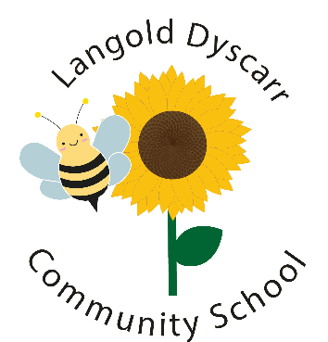
Langold Dyscarr Community School

School Council Action Plan
2022-2023

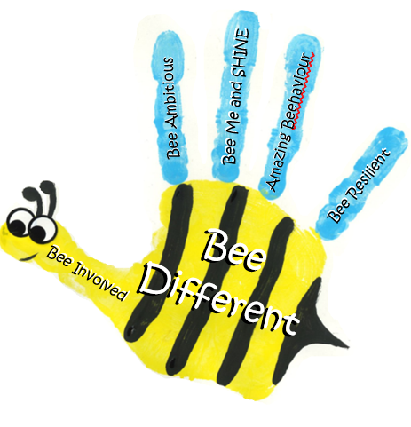
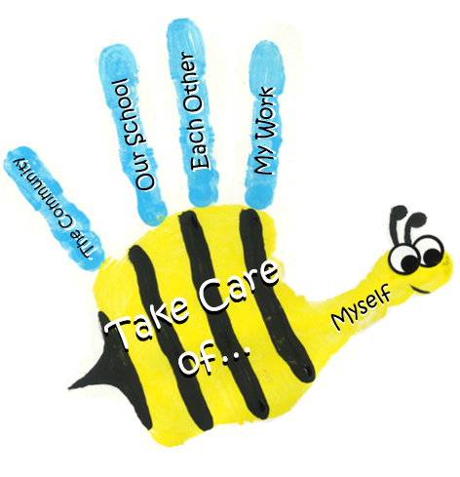

Our School Council Action Plan is a working document, which we have created together and will use to help us complete tasks, adapt and review as the year progresses.
CommunityEnvironmentRelationshipsHealth/wellbeing

Target | Specific actions | Success criteria | Milestones
Target | Specific actions | Success criteria | Autumn | Spring | Summer
To elect a new School Council committee for the school year 2022-2023. | -Manifestos  -Election/celebration and badges  -School Council assembly  -Create action plan | -2 children from each class elected.  -Meet school governors and receive badges.  -School council to deliver an assembly to whole school.  -Action plan to include ideas from manifestos.
To implement a Buddy Bench. | -Discuss and agree outcomes of Buddy bench.  -Create character for sign  -Create signal for peers to buddy with children who need it. | -Agree on a plan to create and implement the buddy bench.  -Sign designed using wally the worry monster as inspiration.  -Signal created for children to use to let peers know they need a buddy.
Meet and work with the Parent Bee group. | -Work together with parent Bee group on any fundraising or event ideas. | -Meet parent bee group  -Share ideas together  -Give pupil voice feedback
Helping and supporting our community. | -Regularly take part in or support Langold community events. E.g Food banks, litter picks, allotments. | -To support any community events where possible.  -To think about and include our community within our discussions for improvement.
Complete a community litter pick with the Eco-Committee. | -Organise a community litter pick with the Eco-Committee’s support. | - A community litter pick with Eco-Committee and some of the community/parents.
To research walk to school bus. | -Research into walking school bus for the local community. | -Have ideas of logistics for walking bus.  -Have adult helpers  -Arrange a trial.
Begin to plan and design a mindfulness area in the school playground and to promote more mindfulness walks and activities out in local nature. | -Pupil voice ideas for mindfulness area.  -Ideas to promote mindfulness walks etc. | -Gathered ideas from pupils about what the mindfulness area would need.  -Design started (working with OPAL)  -more mindfulness walks/time in nature happening throughout school.
Deliver Random Acts of Kindness (RAKs) to both staff and pupils. | -Create notes, actions, gifts etc to spread happiness and kindness to all. | - Children to have a bank of ideas for RAKS.  -Children to regularly deliver RAKs.

Other actions completed throughout the year so far:
- Helped to promote Cycle to School Week by encouraging peers to cycle and celebrating them when they did
- Positive play vouchers for Anti-bullying
- Collecting ideas and voting for school animal names
- Beginning to create buddy bench posters and brainstorming ideas for a signal
- Creating signs for the school animals
- School Council suggestions looked at regularly

