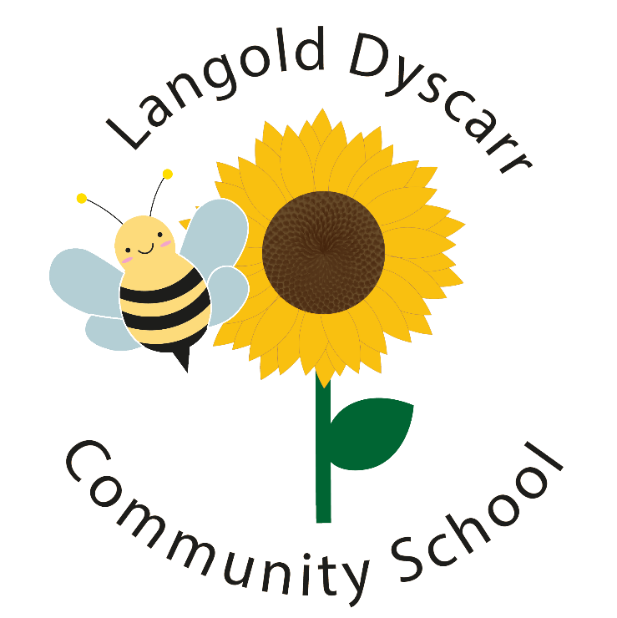

Key Instant Recall Facts
KIRFs
To help develop children’s fluency in mathematics, we ask them to learn Key Instant Recall Facts each half term. We expect children to practise their KIRFs at least 3 times a week.

These lists of KIRFs align with the new curriculum.
They designed to be challenging and it is intended that children will be taught the necessary maths in lessons beforehand.

Key Instant Recall Facts
Year 2 – Autumn 1
I know number bonds to 20.
By the end of this half term, children should know the following facts. The aim is for them to recall these facts instantly.
Key Vocabulary
What do I add to 5 to make 20? What is 20 take away 6?
What is 3 less than 20?
How many more than 16 is 20?
0 + 20 = 20  1 + 19 = 20  2 + 18 = 20  3 + 17 = 20  4 + 16 = 20  5 + 15 = 20  6 + 14 = 20  7 + 13 = 20  8 + 12 = 20  9 + 11 = 20  10 + 10 = 20 | 20 + 0 = 20  19 + 1 = 20  18 + 2 = 20  17 + 3 = 20  16 + 4 = 20  15 + 5 = 20  14 + 6 = 20  13 + 7 = 20  12 + 8 = 20  11 + 9 = 20 | 20 – 0 = 20  20 – 1 = 19  20 – 2 = 18  20 – 3 = 17  20 – 4 = 16  20 – 5 = 15  20 – 6 = 14  20 – 7 = 13  20 – 8 = 12  20 – 9 = 11  20 – 10 = 10 | 20 – 20 = 0  20 – 19 = 1  20 – 18 = 2  20 – 17 = 3  20 – 16 = 4  20 – 15 = 5  20 – 14 = 6  20 – 13 = 7  20 – 12 = 8  20 – 11 = 9

They should be able to answer these questions in any order, including missing number questions e.g. 19 + ⃝ = 20 or 20 – ⃝ = 8.

Top Tips

The secret to success is practising little and often. Use time wisely. Can you practise these KIRFs while walking to school or during a car journey? You don’t need to practise them all at once: perhaps you could have a fact of the day. If you would like more ideas, please speak to your child’s teacher.

Use what you already know – Use number bonds to 10 (e.g. 7 + 3 = 10) to work out related number bonds to 20 (e.g. 17 + 3 = 20).

Use practical resources – Make collections of 20 objects. Ask questions such as, “How many more conkers would I need to make 20?”

Make a poster – We use Numicon at school. You can find pictures of the Numicon shapes online – your child could make a poster showing the different ways of making 20.

Play games – You can play number bond pairs online at www.conkermaths.org and then see how many questions you can answer in just one minute.

