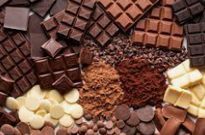
Chocolate!
Autumn 1- Can you have a go at completing these activities at home?
Make sure you bring your work in to share with the class.
Science/Technology
Compare two different chocolate bars and say which you prefer and why. List similarities/differences
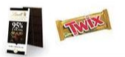
Spring – Homework menu
Create
Make your own chocolate factory using recycled materials, lego, playdoh, clay etc.
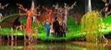
Chocolate fact file
Collect facts about chocolate. Think about where it comes from, what it is made of, the different types and famous brands.
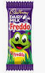
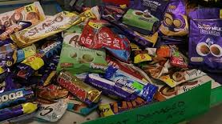
Can you have a go at completing these activities at home?
Create
Design a poster to advertise your favourite chocolate bar.

Food technology
Design and make a menu for a 3-course chocolate meal! Remember, everything must contain chocolate.

English
Write a chocolate inspired poem and decorate the page
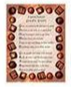
Create
Design a brand-new chocolate bar. Give it a name and draw it.

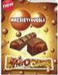
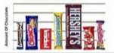
Make sure to bring it in to share with the class. J
Maths
Ask your friends and family about their favourite chocolate and present results in a tally or bar chart.

