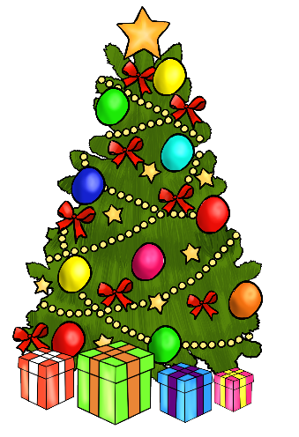
How did it start?
The tradition of gift giving began with the wise men who brought gold, frankincense and myrrh for Jesus. However, the tradition of Father Christmas, or St. Nicholas as he was originally known, dates back to 280AD where the legend of St. Nicholas began and his reputation for giving away his wealth and devoting his life to helping those in need began. In later years, his legend become commercialised and the birth of Santa Claus and Father Christmas began.
How does it end? Christmas draws to an end on the Twelfth Night, which is said to be the deadline for all Christmas festivities to end and all decorations and trees to be removed until the next year’s celebrations.

Ways people celebrate Christmas:-
Advent is the time of waiting for Christmas, which marks the arrival of Jesus to earth just over 2000 years ago. Advent begins on the Sunday nearest to the 30th November and lasts until Christmas Eve. Many children celebrate this using an advent calendar where as many Christians use an advent candle.
Christingle celebrates the light of Jesus around the world and involves creating a Christingle using an orange, to symbolise the world; sweets and raisins, to symbolise the gifts of God; red tape, to symbolise the love and blood of Christ; and a candle, to symbolise the light of Jesus. Our first Christingle service took place at Lincoln Cathedral in 1968 and every year churches across the world continue this tradition.
Christmas carols often celebrate different parts of the birth story of Jesus. However, some are more focused on traditions associated with Christmas and are sung as general celebrations of the Christmas festival.
Christmas dinner is traditionally eaten on Christmas Day as a feast to celebrate the birth of Jesus. The dinner is commonly a Turkey roast and is a time for families to come together and spend time together.
Why do Christians celebrate Christmas?
Christians celebrate in many different ways from very religious ceremonies or just traditions with families; however, the one thing that is common throughout all celebrations is the birth of Jesus Christ, also known as The Nativity. This story follows the journey of the Virgin Mary who is told she is pregnant with the son of God by the Angel Gabrielle. Both Mary and Joseph must travel to Bethlehem and this is where Jesus is to be born in a stable amongst the animals, as there was no room at the inn. The birth is announced to by the angels to shepherds, who join the scene as well as and three wise men who must follow a star to the son of God. Christmas is called by some, Jesus’ birthday as it celebrates the birth of baby Jesus, the son of God.
What is Christmas and who celebrates it?
Christmas is one of the biggest Christian celebrations across the world, where families come together to celebrate the birth of Jesus. Christians celebrate Christmas each year on the 25th December and truly believe that the ‘True Meaning of Christmas’ involves showing gratitude to God for what he did and remembering the birth of Jesus Christ, by worshipping him, giving gifts and thinking of the poor and less fortunate. Families spend time together celebrating and remembering how fortunate they are.
The true meaning of Christmas

