Mini-quiz #1
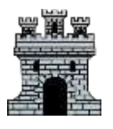Medieval Britain

- When did the Battle of Hastings happen?
- 1056
- 1066
- 1076

- Who fought at the Battle of Hastings?
a) Edward the Confessor
b) William of Normandy
c) Harald Hardrada

- What two buildings did most medieval cities have?
- A church and castle
- A castle and school
- A church and sports pitch

- Who was at the top of the Feudal system?
- Knight
- Lord
- King

- If you committed a crime, you could be hanged…
TRUE or FALSE

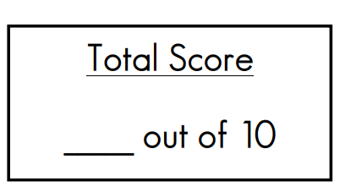
- What was a ‘mound and enclosure’ with castles made of wood and earth known as?
a.) Windsor Castle
b.) wattle and daub
c.) motte and bailey

- Which of these is a feature of stone castle?
- A bailey
- Arrow slits
- Keep

- Who commissioned the Domesday Book?
- Edward the Confessor
- William the Conqueror
- King Harold

- When did the Magna Carter finally become law?
- 1066
- 1301
- 1227

- How was the Black Death transmitted?
- Food
- Blood
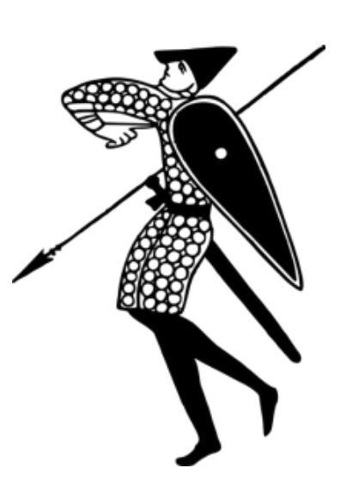
- Fleas on rats

Mini-quiz #2
Medieval Britain
- What famous artefact depicts the Battle of Hastings?
- Windsor Castle
- Bayeux Tapestry
- Domesday Book

- Who died at the Battle of Hastings?
- William of Normandy
- Harold Hardrada
- King Harold

- What were the poorer people called?
- Nobles
- Peasants
- Vassals

- What material were most Medieval houses made of?
- Brick
- Stone
- Wood

- Which part was built on a mound?

Motte or Bailey

- What were used to fire large rocks or fireballs?
- Catapults
- Cannons
- Guns

- When was the Domesday book drawn up?
- 1086
- 1096
- 1066

- Who was forced to sign the Magna Carter?
- King Harold
- King William
- King John

- What was the first sign of the Black Death?
- Black spots
- Boils under your arms
- Sneezing

- What were the names of the Two Princes?
- Edward and Richard
- John and James
- Richard and Harold

Mini-quiz #3
Medieval Britain

- What battle killed Harald Hardrada?
- Battle of Hastings
- Battle of the Kings
- Battle of Stamford Bridge

- How long is the Bayeux Tapestry?
- 70m
- 50m
- 30m

- What other name could Lords be known as?
- Knight
- Noble
- Peasant

- England was divided into…
- Manors
- Farmlands
- Battle fields

- What was the purpose of the gateway?
- Kept vermin out
- Prevented people entering under attack
- Kept the warmth in

- Stone castles were cheaper to build than Motte and Bailey…
TRUE or FALSE

- How long did the Domesday Book take to write?
- One year
- 6 months
- 18 months

- What was the purpose of the Magna Carter?
- To limit the Kings powers.
- To limit the powers of the people.
- It had no purpose.

- Which nursery rhyme tells of the Black Death?
- Baa Baa Black Sheep
- Humpty Dumpty
- Ring-a-Ring O’ Roses

- What did the beak mask have in the end?
- Straw and herbs.
- Medicines
- Nothing

