Q1.
This table shows the areas of the United Kingdom and Jamaica.

Country | Area  (square kilometres)
United Kingdom | 240,000
Jamaica | 10,000
The area of the United Kingdom is larger than the area of Jamaica.
How many times larger is the United Kingdom?
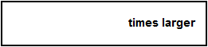
1 mark
Q2.
Large pizzas cost £8.50 each.
Small pizzas cost £6.75 each.
Five children together buy one large pizza and three small pizzas.
They share the cost equally.
How much does each child pay?

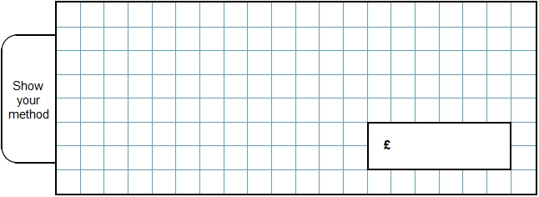
2 marks

Q3.
Shenaz buys a pack of 24 cans of cola for £6.00

What is the cost of each can?

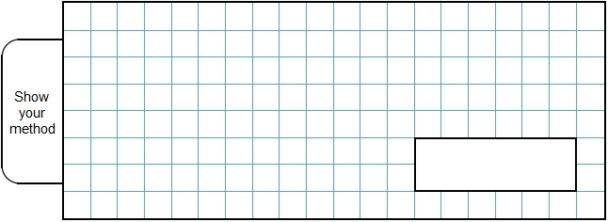
2 mark
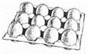Q4.
Eggs are put in trays of 12
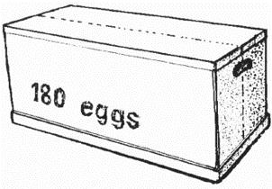

The trays are packed in boxes.

Each box contains 180 eggs.
How many trays are in each box?

2 mark
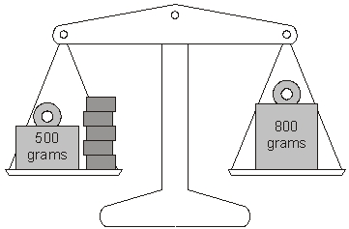Q5.
Lin has five blocks which are all the same.
She balances them on the scale with two weights.

Calculate the weight of one block.

2 marks
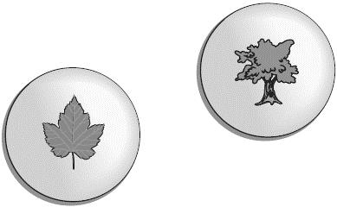Q6.
Forest School sells badges for charity.

For each badge sold, £1.20 is given to a charity.
How much does the charity get when 12 badges are sold?
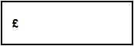
1 mark
If the charity got £24, how many badges were sold?
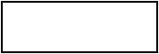
1 mark
Q7.Write what the three missing digits could be in this calculation.
 | × |  | = | 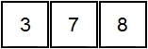

1 mark
Q8.Amina posts three large letters.
The postage costs the same for each letter.
She pays with a £ 20 note.
Her change is £14.96
What is the cost of posting one letter?
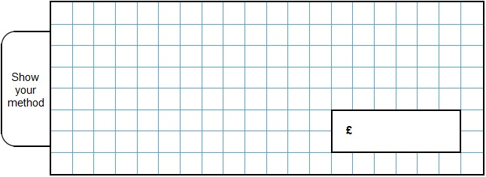
2 marks
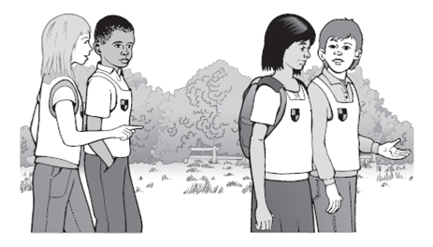Q9.Seb goes on a sponsored walk to collect money for charity.
His aunt promises to pay 75p for each kilometre he walks.
She pays him £6.75 at the end of the walk.
How many kilometres does Seb walk?
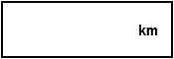
1 mark
15% of the people walk 5 km or less.
40% of the people walk 8 km or more.
What percentage of the people walk between 5 km and 8 km? 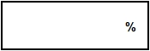
1 mark
Q10.
Write the missing number.
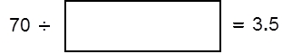
1 mark

Mark schemes
Q1.
24
[1]
Q2.
Award TWO marks for the correct answer of £5.75
If the answer is incorrect, award ONE mark for evidence of an appropriate method, e.g:
• £6.75 × 3 = £20.25
£20.25 + £8.50 = £28.75
£28.75 ÷ 5
Answer need not be obtained for the award of ONE mark.
Up to 2
[2]
Q3.
Award TWO marks for the correct answer of 25p OR £0.25 OR 25 pence.
If the answer is incorrect, award ONE mark for evidence of appropriate working,
eg 600 ÷ 24 = wrong answer.
Accept £0 25 OR £0.25p OR £0 25p OR 25 OR 0.25 OR £0-25.
Calculation must be performed for the award of ONE mark.
Up to 2
[2]
Q4.
Award TWO marks for a correct answer of 15
If the answer is incorrect, award ONE mark for evidence of appropriate
working, eg
180 ÷ 12 = wrong answer
Calculation must be performed for the award of ONE mark.
Up to 2
[2]
Q5.
Award TWO marks for the correct answer of 60
If the answer is incorrect, award ONE mark for evidence of appropriate
method, eg
800 – 500 = 300
300 ÷ 5
Answer need not be obtained for the award of ONE mark.
Up to 2 (U1)
[2]
Q6.
(a) £14.40
Do not accept £14.4
1
(b) 20
Do not accept £20
1
[2]
Q7.
Calculation completed correctly as shown:
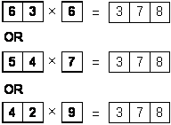
[1]
Q8.
Award TWO marks for the correct answer of £1.68
If the answer is incorrect, award ONE mark for evidence of an appropriate method, e.g.
• 20 − 14.96 = 5.04
5.04 ÷ 3
Accept for ONE mark an answer of £168 OR £168p as evidence of an appropriate method.
Answer need not be obtained for the award of ONE mark.
Up to 2m
[2]
Q9.
(a) 9
1
(b) 45%
1
[2]
Q10. 20[1]

