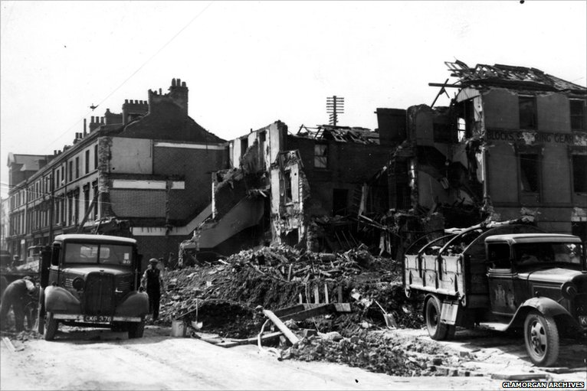
horse-drawn round to find his employer Bill Hollyman's baker shop reduced to rubble. He said to The Daily News, ‘‘I was shocked there was debris everywhere, it was unrecognisable!’’
Another witness to the devastating bombings was Margaret, aged 45, who said she heard an almighty explosion, followed by flashes of white light littering the night sky, and ferocious flames raging.
With the war still ongoing, it is important to remember to; always carry your gas mask, find the nearest Anderson shelter and never leave your lights on at night time.

Last week, in Cardiff, the nasty Nazi Luftwaffe, dropped hundreds of bombs in the busy area of Riverside, whilst innocent people slept peacefully in their beds.
Tragically, it is thought that around 100 people have been killed and 350 homes destroyed, with many people still missing. However, a lucky few with Anderson Shelters in their back gardens managed to seek refuge and survive the terrifying attack.
Also damaged in the air raid, which lasted 10 hours, was Llandaff Cathedral, Cardiff Docks and many Chapels in the town centre.
The worst incident was at the home of a bakers, on the corner of Stockland Street in Grangetown. Around 32 people were killed - including at least five members of the Hollyman family as they sheltered in the cellar under the bakery. The bomb when it hit left an enormous pile of rubble (around 3 metres high).
A local lad, John Williams, a 14-year-old delivery boy for the bakery, arrived the next morning for his

Written by B. Davis
B
Above: Damage to the houses and bakery in Stockland street, Riverside.
January 9th 1940
Bomb Blasts Bakery

