CATASTROPHE IN COVENTRY
November 15TH 1940
By Lauren Fincham, War Correspondent

Last night, the Luftwaffe launched an unprecedented assault on Coventry. At 9.10pm, as the air raid sirens echoed across the city, the first explosions occurred.

As the lightning war broke out, eyewitnesses reported that a cloud of German bombers filled the sky, dropping incendiary bombs like rain. They hit the ground with their curious and distinctive sound and then erupted in a sizzle of bluish-white flame. The sky, already clear from the full moon, was painted red as the streets filled with mass hysteria.

Bombs fell for most of the night, as an estimated 500 German planes bombarded the city. Fire then consumed those buildings, which the bombs were yet to devour. It is estimated that the German bombers have claimed over 500 lives and destroyed more than 2,000 houses. This is despite government assistance in providing public and private shelters.

Courageous fire fighters and members of the public alike, battled bravely against the flames. However, craters in the street left fire engine unable to reach the largest fires.

It is thought that Adolf Hitler had long ago chosen Coventry as a target for bombing, due to its status as a hub of industry and engineering. At least 100 factories have been destroyed, halting production of essential supplies, including armoured vehicles for the front line.

At 15 Trensdale Street, Cowden, one gentleman reported that bombs had landed on either side of his home simultaneously, not more than 20 metres away. He commented, “It was a miracle that my wife and I weren’t killed. We moved not one jot from our Morrison shelter until the all clear sirens sounded this morning. The sounds were enough to make you feel your life was soon to be over.”

Daniel Johnson, who spent most of the night in a community Anderson Shelter, told us “When I returned to my bedroom the windows were smashed and my bed was covered in large shards of glass. When I looked out the kitchen window, I saw an unexploded bomb just lying in the garden. I didn’t know what to do!”

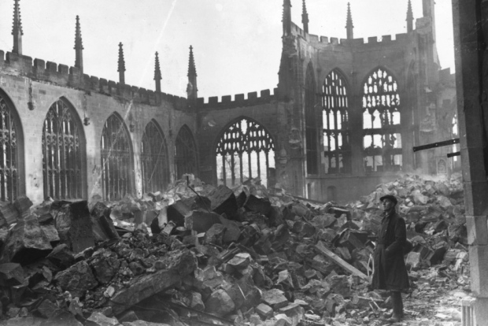
Coventry Cathedral bombed beyond repair.

Devastatingly, Coventry Cathedral was badly hit just before midnight. This beautiful and historical building, known as the bright beacon of the city, is now a shell of its former self. This is a real blow for the people of Coventry who have suffered so much in the last 24 hours.

Despite the worst attack so far, local people have been working together to clean the city this morning and keep people’s spirits up. Old and young are pulling together to contribute to the war effort.

Prime Minister Winston Churchill is reported to be planning a visit to the city, to survey the wreckage, as soon as possible. However, as the smoke clears today, the residents of this confounded city can only wait to see if another wave of fighter planes are on their way. They plead for Hitler’s mercy and an end to this war.

