To describe what happened during some key
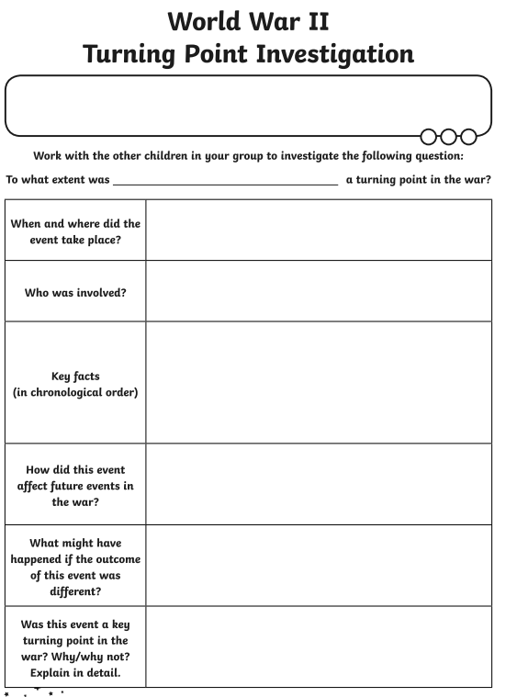
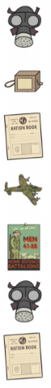
events from World War II

