Forces
Gravity is a pulling force.
It is the gravitational force from the Earth pulls in a direction towards the centre of the Earth.
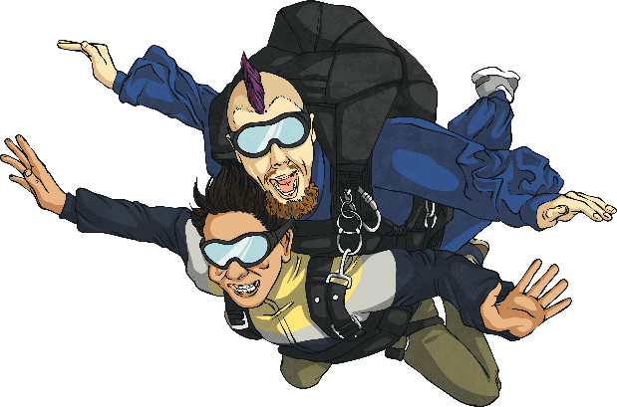
Mass is a measure of the amount of ‘stuff’ inside an object, and is measured in kilograms (kg).
Weight is actually a measure of the strength of gravity acting on an object. It is measured in newtons (N).
The weight of an object is caused by gravity pulling it down. Objects with more mass have a greater weight, as the force of gravity pulls them down more strongly.
Forces are pushes or pulls.
We use an arrow to show when a force is in action.
The direction of the arrow shows the direction in which the force is acting. The bigger the arrow, the bigger the force.
Balanced forces
If two forces are balanced, it means the forces are the same size but are acting in opposite directions.
If two balanced forces are acting on an object, that object will not change its motion. If it is still, the object will stay still or if it is moving, it will continue moving in the same direction and at the same speed.
Unbalanced forces
When two forces acting on an object are not equal in size, we say that they are unbalanced forces. Unbalanced forces do change the way something is moving.
They can make objects start to move, speed up, slow down or change direction
Friction is a force that is caused whenever one object slides over another object. The friction between these surfaces resists the movement. Friction always acts in the opposite direction to the direction the object is moving.
Two very smooth surfaces = Little friction therefore they slide easily over each other.
Rough or uneven surfaces = Greater friction therefore movement is more difficult.
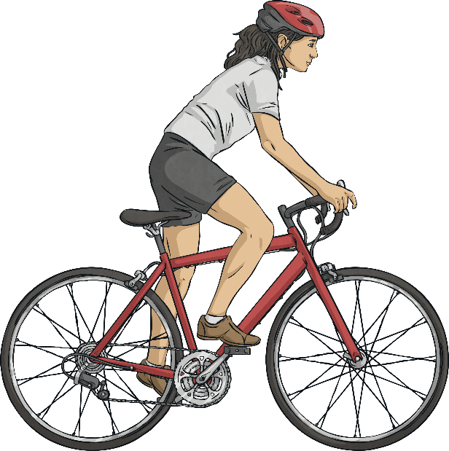 Friction

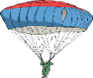
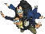
Water Resistance is the force caused when something moves through water. It is the friction caused between the water and the object.
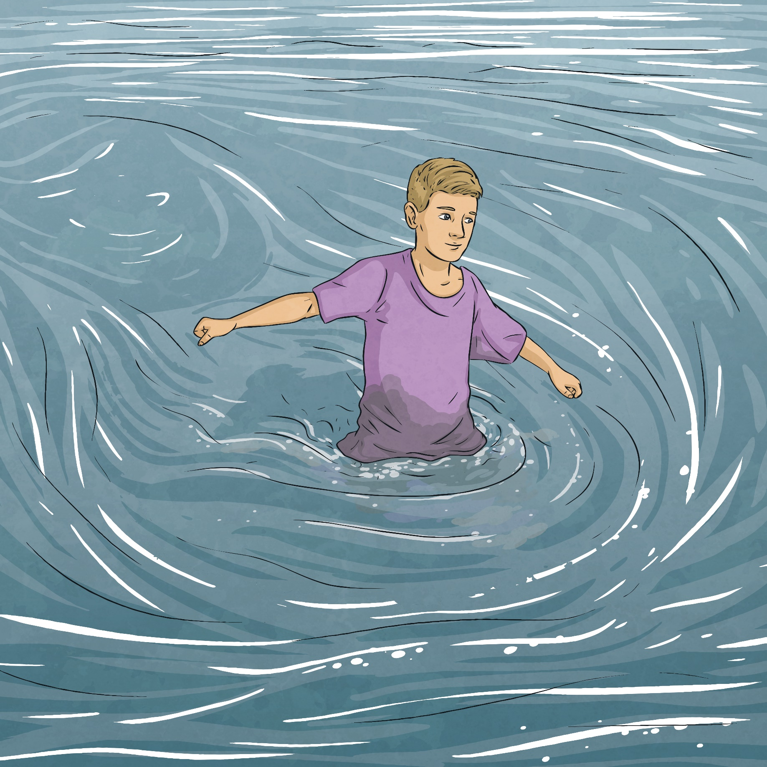 WR
Objects that do not experience much water or air resistance are described as streamlined.
Streamlined objects are often pointed with a smooth, low curved back to allow the water to flow over and around it.
A flat surface creates a lot of water resistance as the water pushes against the flat surface slowing it down.
Air Resistance is a force that slows down a moving object. Objects that move through the air experience air resistance. It acts against gravity.
The wider or larger an object the greater the air resistance because it has a greater upward force on the object.
The smaller or slimmer an object the less the air resistance because it has a smaller upward force on the object.

Buoyancy (or Upthrust) is a force that pushes objects that are in water upwards.

buoyancy

Forces can:
- Affect the movement of an object.
- Make an object start to move.
- Make an object stop moving.
- Make an object go faster.
- Make an object slow down.
- Make an object change its shape.
- Make an object change direction.

